Key features of C++20 standard

1 c++ evolution

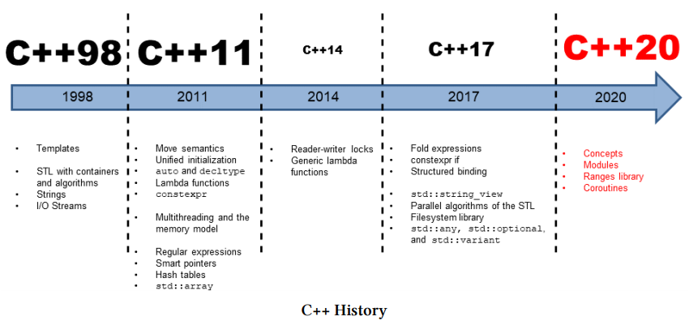

Picture from Grimm Rainer book "C++20 - Get the Details".

Full history of C++ from 1979 on c++ reference site.

2 Feature testing macros
The standard defines a set of preprocessor macros corresponding to
C++ language and library features introduced in C++11 or later.
examples of feature testing macros
__cpp_concepts -Concepts
__cpp_lib_concepts -Standard library concepts
__cpp_impl_coroutine -Coroutines compiler support
__cpp_lib_coroutine -Standard library Coroutines
__cpp_consteval
__cpp_constexpr
__cpp_lib_chrono
__cpp_generic_lambdas
__cpp_impl_three_way_comparison
__cpp_lib_three_way_comparison
Full list of all current macros:

2.1 Compiler support for C++20

C++ Compiler -> Features matrix

3 C ++ 20 features grouped by topic
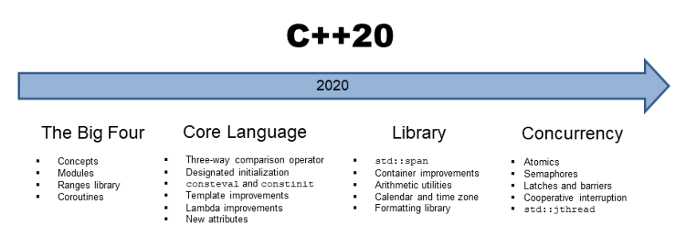
Picture from Grimm Rainer book "C++20 - Get the Details".

4 The Big Four of C++20
The Big Four

4.1 Ranges library
The ranges library provides components for dealing with ranges of elements, including a variety of view adapters.

4.2 Coroutines
A coroutine is a function that can suspend execution to be resumed later.

4.3 Concepts
Class templates, function templates, and non-template functions (typically members of class templates) may be associated with a constraint, which specifies the requirements on template arguments, which can be used to select the most appropriate function overloads and template specializations.
Named sets of such requirements are called concepts. Each concept is a predicate, evaluated at compile time, and becomes a part of the interface of a template where it is used as a constraint:
Standard library header <concepts>
The Concepts library provides definitions of fundamental library concepts that can be used to perform compile-time validation of template arguments and perform function dispatch based on properties of types

4.4 Modules
Modules are a language feature to share declarations and definitions across translation
units. They are an alternative to some use cases of header files.
Modules are orthogonal to namespaces.

5 Core Language

5.1 spaceship operator,3-way comparisons
The compiler performs quite a clever job when it generates all six comparison operators.
Default comparisons

5.2 aggregate initialization
Aggregate initialization

5.3 consteval and constinit
Consteval - specifies that a function is an immediate function, that is, every call to the function must produce a compile-time constant
constinit - asserts that a variable has static initialization, i.e. zero initialization and constant initialization, otherwise the program is ill-formed.

5.4 Template improvements
generic constructor

5.5 Lambda improvements
lambdas features with c++20

6 Library

6.1 std::span library
The class template span describes an object that can refer to a contiguous sequence of objects with the first element of the sequence at position zero.
std::span

6.2 Container improvements
containers with c++20

6.3 Arithmetic utilities
safe comparisons of integrals with c++20
mathematical constants
bit manipulation

6.4 Calendar and time zone library
calendar and time zone in c++20

6.5 Formatting library
The text formatting library offers a safe and extensible alternative to the printf family of functions. It is intended to complement the existing C++ I/O streams library and reuse some of its infrastructure such as overloaded insertion operators for user-defined types.
Formatting library

7 Concurrency

7.1 Atomics
Atomics

7.2 Semaphores
semaphores in c++20

7.3 Latches and bariers
latches in c++20
barriers
barriers in c++20

7.4 Cooperative Interruption
cooperative interruption of a thread in c++20

7.5 std::jthread
jthread

7.6 Synchronized outputstreams
synchronized outputstreams

8 project with examples:
cpp_std_test repository

9 used materials:
C++ reference
Grimm Rainer's book "c++20 - Get the Details"
Grimm Rainer's site "modernes c++"
Grimm Rainer's site "all in one c++20 guide"

